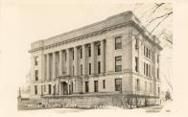
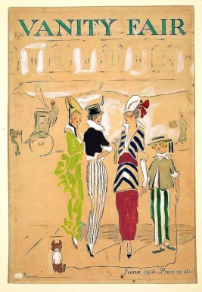
MOODY COUNTY
TIME CAPSULE OPENING CELEBRATION
100 Years
JULY 4, 2014
9:00 a.m. until 2:00 p.m. on the Courthouse Lawn
- GAMES FOR ALL AGES
- PRIZES
- VENDORS/FOOD
- BAND CONCERT
- HORSE AND TRACTOR WAGON RIDES
FOR THE LADIES - Best dress and hat from 1914
FOR THE GENTLEMEN - Best beard and mustache
TIME CAPSULE OPENING AND PROGRAM FROM 1:00 to 2:00 p.m.
PLEASE COME JOIN US!!
Get vendor application on this website

