Welcome to Moody County 4-H!
We’re so glad that you’ve joined 4-H! Here is some information about 4-H to get you started. If you have any additional questions or need more information, please contact the Extension Office at 997-2469 or moody.county@sdstate.edu.
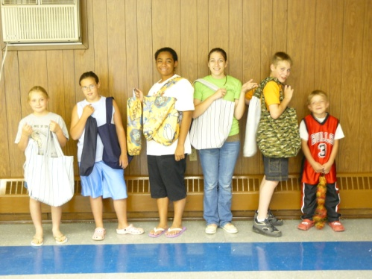

What do the H’s stand for?
They stand for Head, Heart, Health, and Hands, which are parts of the 4-H Pledge.

4-H Pledge
(movements in parentheses)
I pledge my Head to clearer thinking,
(use one hand to touch head)
My heart to greater loyalty
(place right hand over heart)
My hands to larger service,
(hold both hands palm up)
My health for better living,
(hands at sides)
For my club, my community, my country, and
my world.

4-H Motto: To make the best better!

4-H Age and eligible ages
4-H is open to youth ages 8 – 19 (4-H age). A child needs to be 8 on January 1st before they can participate in most 4-H activities (they can begin attending meetings in October). They can stay in the 4-H program, until they are 19 on January 1st.

4-H Ages are broken into 3 groups (category determined by 4-H age – the child’s age as of January 1st of the current year)

Beginners – Ages 8-10
Juniors – Ages 11-13
Seniors – Ages 14 and higher

These age groups are used to determine contest groups and project requirements.

4-H Clubs
Joining a 4-H club is one way to participate in 4-H. These clubs are led by volunteer leaders and meet several times during the year. Club meetings include club business, speeches or demonstrations by members, activities, and projects. Clubs also participate in community service projects and may go on club picnics or trips. 4-H clubs include 4-H members of all ages and of all interests.

The Extension Office keeps a current list of 4-H clubs. We encourage new families to visit a few clubs before deciding which one to join. It’s also possible to switch clubs, if you find one that suits your child better.

Project Groups
Project groups are focused on a specific project. They usually meet for just a portion of the year and hold practices rather than business meetings. Examples of project groups are Shooting Sports/Archery, Horse and Dog.

A 4-H member can belong to a 4-H club and a project group or choose to belong only to a project group. All 4-H members are welcome to participate in other 4-H activities (4-H camp, County Fair, Youth in Action contests, etc.).

Projects without groups
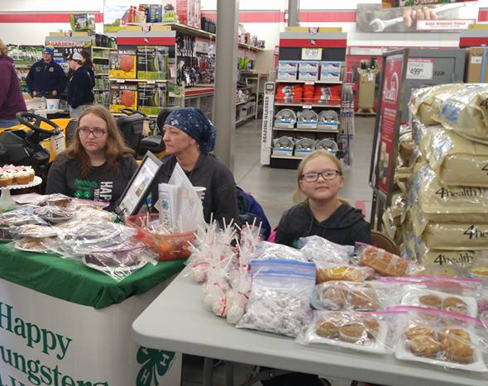
There are over 70 projects that you can be involved with in 4-H! Unfortunately, we don’t have project groups or workshops for all of those projects. The good news? We have resources so that youth can explore these projects at home. In some cases, we can also link 4-H members to a family or community volunteer with experience in that project.

4-H Updates
The best way to stay up-to-date on upcoming events is to read our 4-H Update emails! Our 4-H Updates are usually sent out monthly and include information about upcoming events, opportunities, deadlines, and project information.

Please be sure we always have your current email and home address on file, so you won’t miss anything that we send. You can update it in sd.4Honline.com at any point.

Important Dates
The 4-H year runs from October - September. This is a general schedule of what happens during the 4-H year. Some event dates may vary from year to year. Please watch for 4-H updates for dates and deadlines and contact the Extension Office with questions.

October:
- 4-H Member Enrollment on sd.4Honline.com opens
- 4-H Volunteer on sd.4Honline.com opens
- 4-H Recognition Event

December
- Shooting Sports Organization Meeting
January
- 4-H Member Enrollment on sd.4Honline.com Due
- Shooting Sports Practices Start
March
- Beef Green Tagging/Weigh In
April
- 4-H State Shoot
- Beef Forms Due
May
- Sheep and Goat Weigh In
- Dog Practices Start
- Final 4-H Enrollment information must be in by May 31st
June
- Livestock Affidavits and Lease Forms Due
- 4-H Camp
- Teen Leadership Conference
- County Horse Show
- Youth for the Quality Care of Animal Training Due
July
- Youth in Action Contests
- State Horse Show
- State Livestock Judging Contest
- County Fair Pre-registration Due
- Purebred animal registration forms due
- County Fair
August
- State Dog Show
- South Dakota State Fair
September
- 4-H Journals and Award applications due
- 4-H Scholarship Applications Due
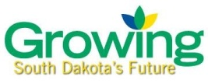

Livestock and Animal Projects
If your child is interested in doing a livestock, horse, or animal project, there are additional deadlines and paperwork you’ll need to complete. Please contact the Extension Office for information about forms and deadlines.

It is very important to have all forms and paperwork completed by the deadlines and to bring required paperwork with you to shows.
Late forms are not accepted.
Late or missing forms will prevent your child from participating in 4-H shows.
Youth in Action Events
In addition to County Fair, we also have Youth in Action events that 4-H members can participate in. Most Youth in Action events are held in June or July. These events are Special Foods, Fashion Revue, Public Presentation and Judging.
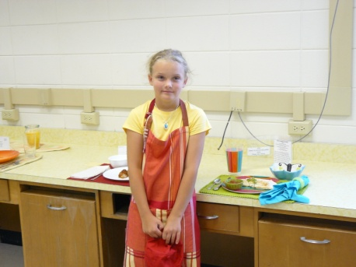
Special Foods Contest: 4-H members cook a recipe for a judge, speak with a judge about the nutrition of that recipe, and bring a decorative place setting to show off their creation.
Fashion Revue: 4-H members have the opportunity to show off and compete with their sewing projects and purchased outfits.
Public Presentation Contest: 4-H members perform a speech or demonstration.
Judging and Skill-A-Thon Contests: Judging contests include livestock, horticulture and consumer sciences.
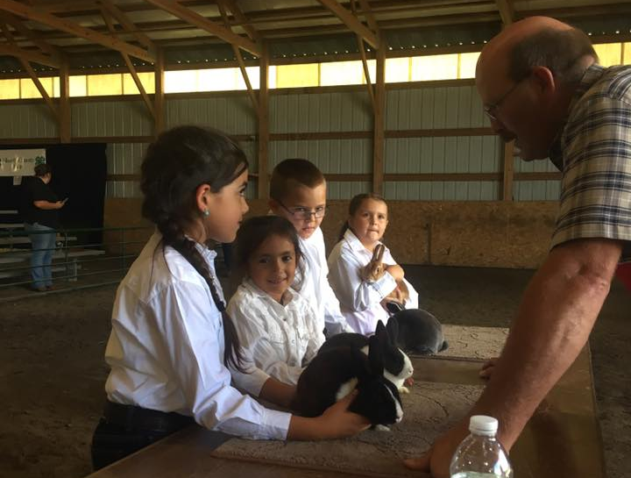
County Fair
County Fair is our 4-Hers opportunity to compete and show off their project work for the year (in some counties this event is called the Achievement Days). There are exhibit classes for all of our project areas. In 2019, County Fair will be July 24th-27th.

Our County Fair classes and rules follow the State Fair Book. The fair book includes all of the contest rules and exhibit classes. They usually come out in the Spring – we will contact you by email when it’s available.

All County Fair entries need to be preregistered. Entries are entered in to a website called FairEntry. We will send out the FairEntry information in May/June.

State Fair
Projects receiving any ribbon placing at County Fair are eligible to go on to the State Fair. All State Fair entries need to be preregistered. We will send out the FairEntry information in July.

For static/indoor exhibits, we will transport those for exhibit at the State Fair if they are reasonable size. All animal exhibits are the responsibility of the 4-H member and their family.

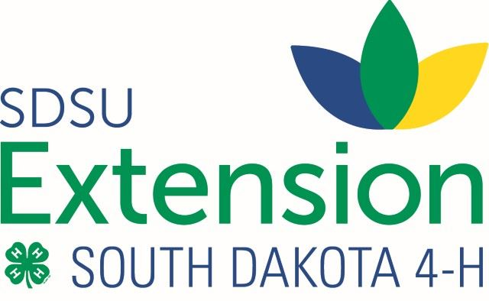

There’s Even More to 4-H!
4-H isn’t just club meetings. There are also camps, conferences, project workshops, leadership trainings, 4-H events, and national trips like Citizenship Washington Focus.
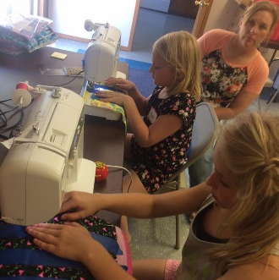
All of these opportunities will be sent out in the monthly updates. Please contact us for more information about any events you read about in the 4-H Updates.

We also have funding to make these opportunities available to all youth. Please don’t hesitate to contact us.

Awards and Record Books
In 4-H, we encourage 4-Hers to set goals and keep a record of their learning from participation and project work.

4-H members fill record books to record their club meetings, activities, community service, and project work throughout the year, including what they learned and the best and most challenging moments.

Most 4-H awards are tied to completion of the 4-H record book. 4-Hers can work on earning pins each year (year and project area pins) and toward larger awards (Citizenship, Leadership, and 4-H KEY awards).

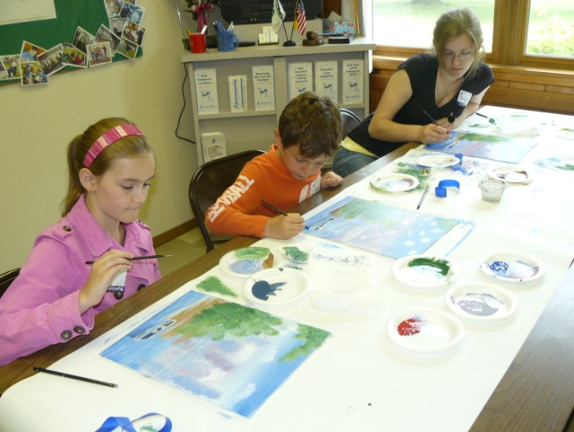
Award applications, booklets and 4-H record books are available at the Extension Office.

Opportunities to be Involved
Parents and family members are an important part of the 4-H program! They’re often needed to help host and assist with 4-H Club meetings.

If you’d like to get even more involved with 4-H, we’d love your help with the Leaders Association, County Fair committees, volunteering for different 4-H events, or chaperoning a 4-H trip or camp.

If you are involved at that level or would like to be, we can help you with the paperwork and answer any questions you have.

One Last Note
The true value of 4-H is what kids learn as they participate – whether it’s responsibility from taking care of an animal, leadership skills from being the vice president of their 4-H club or how not to burn themselves with a glue gun during a craft project.

We ask that parents and adults help our 4-Hers focus on what they can learn. Winning a ribbon or plaque is fun and exciting, but it’s not the purpose of 4-H.

Meet the Extension Office staff!

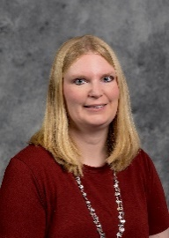
My name is Jen Hayford. I’m the
4-H Youth Program Advisor for Lake and Moody Counties. I’m here to help manage the county 4-H program, and I’d love to help answer any questions you have. You can reach me at 997-2469 or jennifer.hayford@sdstate.edu

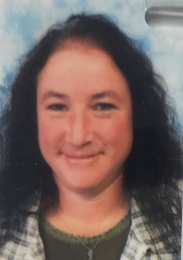
Deb Patterson is the Office Manager/4-H Assistant for the Extension Office. If you have a question, need forms, or are looking for project resources, she’d love to help you out.
Deb can be reached at 997-2469 or at moody.county@sdstate.edu

